|  |  |
| --- | --- |
| Activity | Data Type |
| Number of beatings from Wife | Discrete |
| Results of rolling a dice | Discrete |
| Weight of a person | Continuous |
| Weight of Gold | Continuous |
| Distance between two places | Continuous |
| Length of a leaf | Continuous |
| Dog's weight | Continuous |
| Blue Color | Discrete |
| Number of kids | Discrete |
| Number of tickets in Indian railways | Discrete |
| Number of times married | Discrete |
| Gender (Male or Female) | Discrete |

**Q1)** Identify the Data type for the Following:

**Q2)** Identify the Data types, which were among the following

Nominal, Ordinal, Interval, Ratio.

|  |  |
| --- | --- |
| Data | Data Type |
| Gender | Nominal |
| High School Class Ranking | Ordinal |
| Celsius Temperature | Interval |
| Weight | Ratio |
| Hair Color | Nominal |
| Socioeconomic Status | Ordinal |
| Fahrenheit Temperature | Interval |
| Height | Ratio |
| Type of living accommodation | Ordinal |
| Level of Agreement | Ordinal |
| IQ(Intelligence Scale) | Ratio |
| Sales Figures | Ratio |
| Blood Group | Nominal |
| Time Of Day | Ordinal |
| Time on a Clock with Hands | Interval |
| Number of Children | Nominal |
| Religious Preference | Nominal |
| Barometer Pressure | Interval |
| SAT Scores | Interval |
| Years of Education | Ordinal |

**Q3)** Three Coins are tossed, find the probability that two heads and one tail are obtained?

**Ans**: P (Two heads and one tail) = N (Event (Two heads and one tail)) / N (Event (Three coins tossed))

= 3/8 = 0.375 = 37.5%

**Q4)** Two Dice are rolled, find the probability that sum is

1. Equal to 1
2. Less than or equal to 4
3. Sum is divisible by 2 and 3

**Ans**: a) 0, the lowest possible combination is 2. It is not possible to roll a sum of 1

b) 1/12 is the probability of sum equal to 4, 1/6 is the probability of sum is less than 4.

c) 5/36 is probability of sum is divisible by 2 and 3 with favorable outcomes

**Q5)** A bag contains 2 red, 3 green and 2 blue balls. Two balls are drawn at random. What is the probability that none of the balls drawn is blue?

**Ans**: Total number of balls = (2 + 3 + 2) = 7  
Let S be the sample space  
Then, n(S) = Number of ways of drawing 2 balls out of 7

n(S)=7C2

n(S)= (7×6) / (2×1) = 21  
Let E = Event of 2 balls, none of which is blue  
∴ n(E) = Number of ways of drawing 2 balls out of (2 + 3) balls

n(E)=5C2

n(E)= (5×4) / (2×1) =10

∴P(E)=n(E)n(S) = 10/21

The probability that none of the balls drawn is blue = 10/21

**Q6)** Calculate the Expected number of candies for a randomly selected child

Below are the probabilities of count of candies for children (ignoring the nature of the child-Generalized view)

|  |  |  |
| --- | --- | --- |
| CHILD | Candies count | Probability |
| A | 1 | 0.015 |
| B | 4 | 0.20 |
| C | 3 | 0.65 |
| D | 5 | 0.005 |
| E | 6 | 0.01 |
| F | 2 | 0.120 |

Child A – probability of having 1 candy = 0.015.

Child B – probability of having 4 candies = 0.20

**Ans:** Expected number of candies for a randomly selected child

= 1 * 0.015 + 4*0.20 + 3 *0.65 + 5*0.005 + 6 *0.01 + 2 * 0.12

= 0.015 + 0.8 + 1.95 + 0.025 + 0.06 + 0.24

= 3.09

**Q7)** Calculate Mean, Median, Mode, Variance, Standard Deviation, Range & comment about the values / draw inferences, for the given dataset

a) For Points, Score, Weigh>

b) Find Mean, Median, Mode, Variance, Standard Deviation, and Range and also Comment about the values/ Draw some inferences. (Use Q7.csv file)

**Ans:**

|  |  |  |  |  |  |  |
| --- | --- | --- | --- | --- | --- | --- |
|  | Mean | Median | Mode | Variance | Standard Deviation | Range |
| Points | 3.596563 | 3.69 | 3.07 | 0.28 | 0.53 | 3.59 |
| Score | 3.21 | 3.32 | 3.44 | 0.95 | 0.97 | 3.911 |
| Weight | 17.84 | 17.71 | 17.02 | 3.19 | 1.78 | 8.39 |

b) 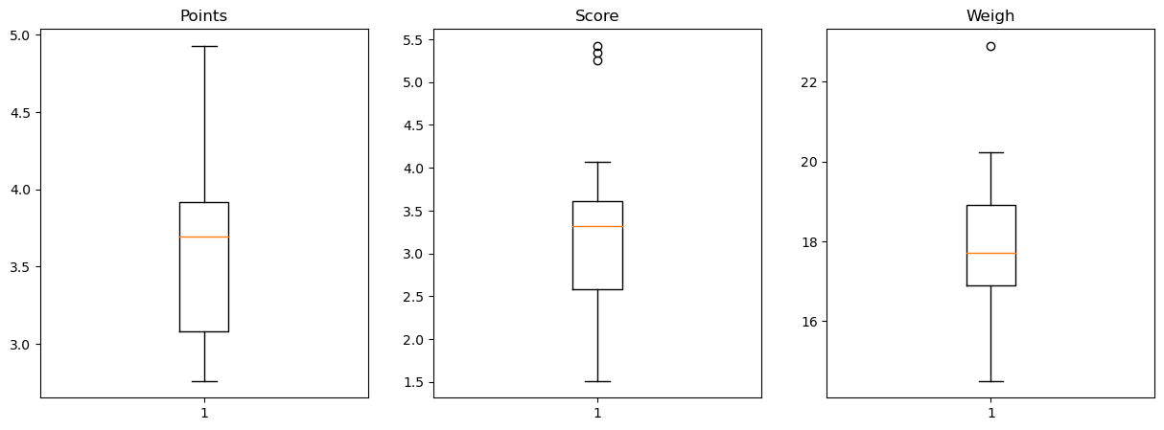

**Q8)** Calculate Expected Value for the problem below

1. The weights (X) of patients at a clinic (in pounds), are

108, 110, 123, 134, 135, 145, 167, 187, 199

Assume one of the patients is chosen at random. What is the Expected Value of the Weight of that patient?

**Ans:** Expected value = (total weight of the patients/total no. of patients)

= (108+110+123+134+135+145+167+187+199) / (9)

= 1308/9 = 145.33

Expected value of weight of that patient = 145.33

**Q9)**

1. **Calculate Skewness, Kurtosis & draw inferences on the following data**

**cars speed and distance (Use Q9_a.csv)**

**Ans: a)** Skewness of Speed = -0.207

Skewness of Dist. = 0.885

Kurtosis of Speed = 2.526

Kurtosis of Dist. = 3.893

**b) SP and Weight (WT) (Use Q9_b.csv)**

**Ans:** Skewness of SP = 1.782

Skewness of WT = -0.790

Kurtosis of SP = 6.492

Kurtosis of WT = 4.220

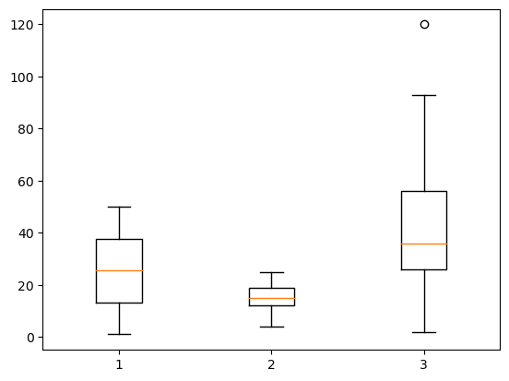

**Q10) Draw inferences about the following boxplot & histogram**



**Ans:** The Histogram’s peak has right skew and tail is on right.

Mean > Median. We have outliers on the higher side



**Ans:** The boxplot has outliers on the maximum side.

**Q11)** Suppose we want to estimate the average weight of an adult male in Mexico. We draw a random sample of 2,000 men from a population of 3,000,000 men and weigh them. We find that the average person in our sample weighs 200 pounds, and the standard deviation of the sample is 30 pounds. Calculate 94%,98%,96% confidence interval?

**Ans:** For 94% Confidence Interval range is (198.73, 201.26)

For 98% Confidence Interval range is (198.43, 201.56)

For 96% Confidence Interval range is (198.62, 201.37)

**Q12)** Below are the scores obtained by a student in tests

**34,36,36,38,38,39,39,40,40,41,41,41,41,42,42,45,49,56**

1. Find mean, median, variance, standard deviation.

**Ans:**

Mean = 41

Median = 40.5

Variance = 25.529

Standard deviation = 5.052

1. What can we say about the student marks?

**Ans:**

We don’t have outliers and the data is slightly skewed towards right because mean is greater than median

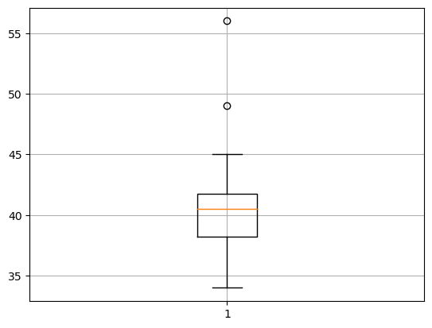

**Q13**) What is the nature of skewness when mean, median of data are equal?

**Ans:** > The data will be perfectly symmetrical

> The Skewness will be = 0

**Q14**) What is the nature of skewness when mean > median ?

**Ans:** > The data will be right Skewness

> Skewness will be ‘+ve’

**Q15**) What is the nature of skewness when median > mean?

**Ans:** > The data will be left Skewness

> Skewness will be ‘-ve ‘

**Q16**) What does positive kurtosis value indicates for a data?

**Ans:** It indicates a sharper peak having kurtosis greater than 3 and not following the normal distribution

**Q17**) What does negative kurtosis value indicates for a data?

**Ans:** It indicates the flat peak having kurtosis less than 3 and not following the normal distribution

**Q18**) Answer the below questions using the below boxplot visualization.



1. What can we say about the distribution of the data?

**Ans:** The above Boxplot is not normally distributed the median is towards the higher value

1. What is nature of skewness of the data?

**Ans:** the data is a skewed towards left. The whisker range of minimum value is greater than maximum

1. What will be the IQR of the data (approximately)?

**Ans:** The inter quantile range Q3 upper quartile – Q1 lower quartile = 18-10= 8

**Q19)** Comment on the below Boxplot visualizations?



Draw an Inference from the distribution of data for Boxplot 1 with respect Boxplot 2.

**Ans:** First there are no outliners. Second both the boxplot shares the same median that is approx. in a range between 275 to 250 and they are normally distributed with zero to no skewness neither at the minimum or maximum whisker range

**Q20)** Calculate probability from the given dataset for the below cases (Data set: Cars.csv)

Calculate the probability of MPG of Cars for the below cases.

MPG <- Cars $ MPG

* 1. P(MPG>38)
  2. P(MPG<40)
  3. P(20<MPG<50)

**Ans:** 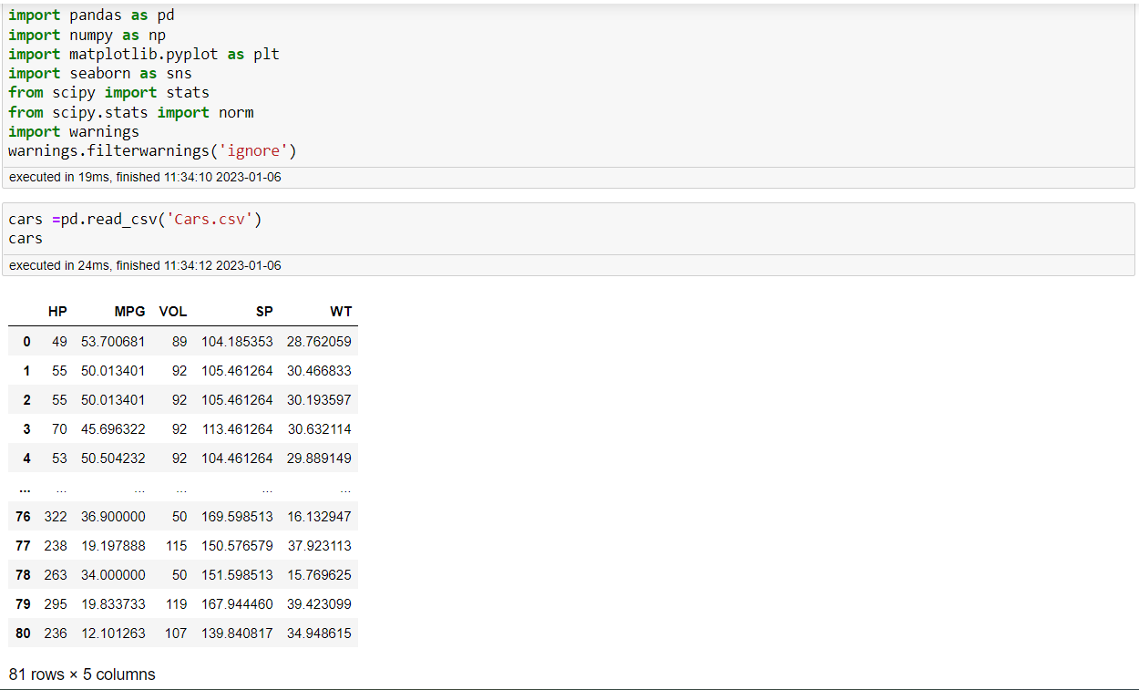

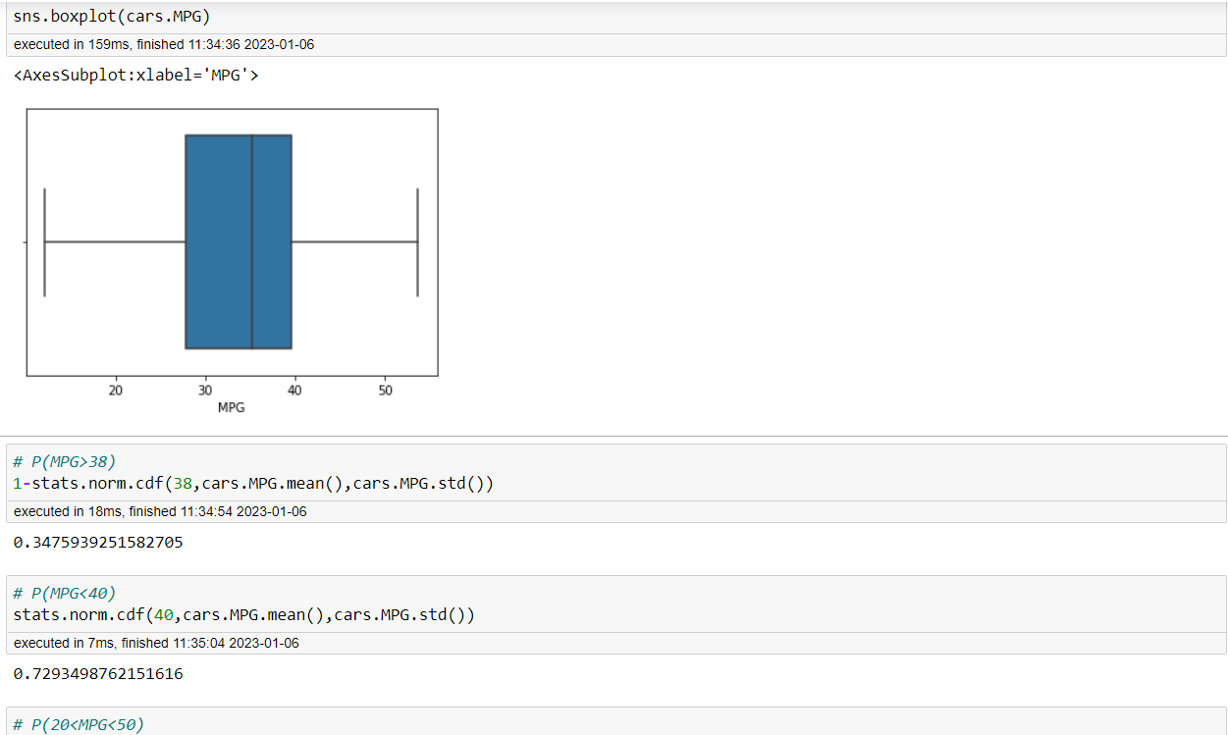



**Q21)** Check whether the data follows normal distribution

1. Check whether the MPG of Cars follows Normal Distribution

Dataset: Cars.csv

**Ans:** MPG of cars follows normal distribution

1. Check Whether the Adipose Tissue (AT) and Waist Circumference (Waist) from wc-at data set follows Normal Distribution

Dataset: wc-at.csv

**Ans:** Adipose tissue (AT) and Waist does not follow Normal Distribution

**Q22)** Calculate the Z scores of 90% confidence interval,94% confidence interval, 60% confidence interval

**Ans:** Z score for 90% Confidence Interval = 1.6449

Z score for 94% Confidence Interval = 1.8807

Z score for 60% Confidence Interval = 0.8416

**Q23)** Calculate the t scores of 95% confidence interval, 96% confidence interval, 99% confidence interval for sample size of 25

**Ans:** T score for 95% Confidence Interval = 2.0689

T score for 96% Confidence Interval = 2.1715

T score for 99% Confidence Interval = 2.7969

**Q24)** A Government company claims that an average light bulb lasts 270 days. A researcher randomly selects 18 bulbs for testing. The sampled bulbs last an average of 260 days, with a standard deviation of 90 days. If the CEO's claim were true, what is the probability that 18 randomly selected bulbs would have an average life of no more than 260 days

Hint:

rcode 🡪 pt(tscore,df)

df 🡪 degrees of freedom

Ans: ) consider,

Ho = average life of bulb >= 260 days

H1 = average life of bulb <= 260 days

import numpy as np

Import scipy as stats

t_score = (x - pop mean) / (sample standard deviation / square root of sample size)

= (260-270)/90/np.sqrt(18))

t_score = -0.471

stats.t.cdf(t_score, df = 17)

0.32 = 32%